

**STUDENT REPRESENTING SUNWAY’S HUMAC**

**MULTI-SENSOR 3KG SUMO ROBOT**

**IN PETROSAINS RBTX CHALLENGE**

**ON 3KG ROBO SUMO OPEN CATEGORY**

by

Edric Ong Khai Jieh, 21040985, American Transfer Degree Programme in Engineering at Sunway College.  

Kho Zi Jian, 20067930, Bachelor of Science in Computer Science (Honours) at Sunway University. 

Ooi Ke Vin, 18058503, Bachelor of Engineering in Electronic and Electrical Engineering with Honours at Sunway University.

|  |  |
| --- | --- |
|  | 4 January , 2023 |

Project title : MULTI-SENSOR 3KG SUMO ROBOT IN RBTX SUMO ROBOT COMPETTION

Date : 30th December 2022

Student : Edric Ong Khai Jieh, Kho Zi Jian, Ooi Ke Vin

Supervisor : Dr Yap Kian Meng

**Abstract**

The 3KG Sumo Robot, Saul, is an autonomous robot built by us at Sunway University. Saul’s function is to push the opponent out of a circular zone and stay in the zone at the same time. To build Saul that can push the opponent out of the circular zone, we implemented multiple sensors and effective motors into the robot with hardware and software tools. Mobility testing showed Saul does not escape the circular zone and follows the object around it autonomously. As Saul resulted in following object around it and do not escape circular zone autonomously, it implies that itself can push the opponent of out a circular zone.

**Table of Contents**

1 Introduction -------------------------------------------------------------------------------------------------------- 3

2 Methodology------------------------------------------------------------------------------------------------------- 4

3 Goals ---------------------------------------------------------------------------------------------------------------- 5

4 Hardware / Software-------------------------------------------------------------------------------------------- 5

5 Conclusion / Future Improvements-------------------------------------------------------------------------- 6

6 Pictures-------------------------------------------------------------------------------------------------------------- 7

7 References --------------------------------------------------------------------------------------------------------- 8

**Introduction :**

The Petronas RBTX 2022 Sumo Robot national championship was a highly competitive event, attracting top talent from across the country. Our team's 3kg sumo robot was able to hold its own against formidable opponents, ultimately earning an impressive 11th place finish. In this report, we will provide an overview of our project and discuss the strategies and technologies employed in the design and construction of our sumo robot. We will also reflect on the lessons learned and challenges encountered during the competition, and suggest areas for improvement for future competitions. Overall, our participation in the Petronas RBTX 2022 Sumo Robot national championship was a valuable and rewarding experience, and we are proud of the hard work and dedication put forth by our team.

**Methodology:**

The methodology employed in our project was designed to maximize the performance and reliability of our sumo robot. The following steps were taken in the design and construction of the robot:

1. Research and planning: We began by researching sumo robot design and competition rules, as well as identifying potential opponents and strategies for success.
2. Design and prototyping: Using computer-aided design (CAD) software, we developed detailed blueprints and prototypes of the robot. We tested and refined these designs through a series of trials and simulations.
3. Fabrication: Once the final design was decided, we sourced the necessary materials and began the fabrication process. This included welding, cutting and shaping the robot's frame, as well as installing the motors, sensors, and other components. Additionally, we also used 3D printing to produce other small components such as mounting brackets and covers for the electronics as well as 3d printed parts for mounting the front shield. This allowed us to produce complex shapes and features that would have been difficult or impossible to achieve using traditional manufacturing methods.
4. Testing and debugging: Prior to the competition, we conducted thorough testing and debugging of the robot to ensure that it was operating at peak performance.
5. Competition: On the day of the competition, we fine-tuned the robot's settings and made any necessary adjustments before each round. We also provided ongoing maintenance and support throughout the event.

**Goals:**

Our main goal for this project was to successfully design, build, and compete with a 3kg sumo robot in the Petronas RBTX 2022 Sumo Robot national championship. This represented our team's first foray into robotics and programming, and we were excited to apply the skills and knowledge we had gained through our studies to a real-world challenge.

In addition to the primary goal of competing in the championship, we also had several other objectives:

* To gain experience in the design and construction of robots, including the use of 3D printing and welding techniques.
* To learn and apply programming skills, particularly in the C++ language, in the development of the robot's embedded system.
* To tinker with microcontrollers, sensors and power system .
* To develop strategies and tactics for success in sumo robot competitions.
* To work as a team and effectively communicate and collaborate in order to achieve our goals.

Overall, our participation in the Petronas RBTX 2022 Sumo Robot national championship was a valuable learning experience, and we are proud of the progress and accomplishments we made as a team.

**Hardware :**

* 1 x Arduino Uno
* 1 x Arduino Uno Screw Shield
* 2 x QTR-1A Reflectance Sensor
* 1 X Sabertooth 2 x 25A Motor Driver
* 5 x Digital Infrared Sensor
* 2 x A58SW31ZY Motors
* 1 x Bluetooth Module HC-05
* 1 x 4s Li – Po battery

**Software Link :**

https://github.com/HealthyFryOption/SumoRobot

**Conclusion and Future Improvements :**

**Conclusion:**

In conclusion, our team is proud of the hard work and dedication that went into the design and construction of our 3kg sumo robot. We are grateful to have had the guidance and support of our supervisor, Dr. Yap, as well as the members of our support team.

There were a few times during the project when we wanted to give up, but we knew we had to keep our promise to finish the robot and not give up halfway, as had happened with Dr Yap’s past students. Despite the challenges we faced, we persevered and were ultimately able to complete the project.

We are proud of the progress we made and the skills we developed throughout this process, and we are grateful to have had the opportunity to participate in the Petronas RBTX 2022 Sumo Robot national championship. This experience was a valuable learning opportunity, and we are excited to apply our newfound knowledge and skills to future projects.

**Future Improvements:**

While we are proud of the progress we made and the results we achieved in the Petronas RBTX 2022 Sumo Robot national championship, there are always areas for improvement. Some suggestions for future improvements to our sumo robot include:

* Building a better arena for testing: Constructing a dedicated testing arena would allow us to more accurately simulate competition conditions and fine-tune the robot's performance.
* Improving the front skid of the robot: The front skid of the robot played a crucial role in its pushing and shoving ability. Making the skid more slanted and sharp would increase its effectiveness in pushing opponents out of the ring.
* Upgrading the infrared sensors: The infrared sensors on our robot were an important part of its perception system, but they had limited range and accuracy. Using higher quality sensors with a longer range would improve the robot's ability to detect and respond to its surroundings.

Overall, these improvements would help to enhance the performance and reliability of our sumo robot, and we look forward to our juniors for implementing them in future projects.

**Pictures :**

1st Prototype

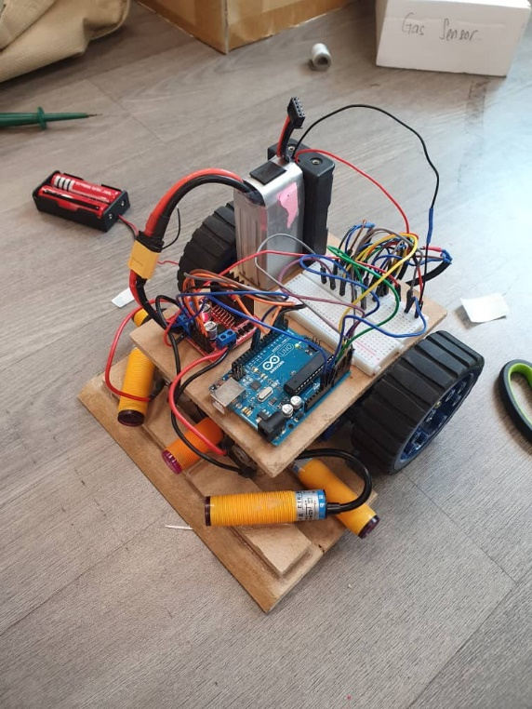

2nd prototype

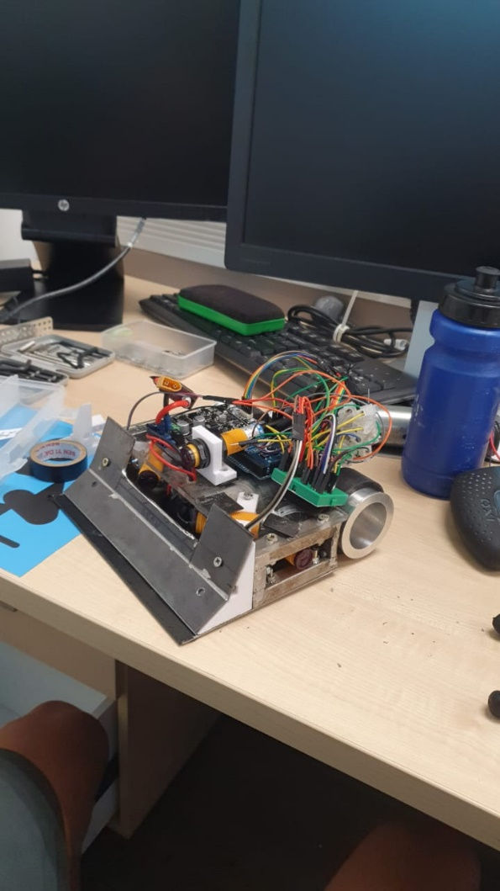

**References :**

*BrooksBots - Strategy for Autonomous Sumo Robot used in ExSpurt & Executioner*. (n.d.). <http://brooksbots.com/Strategy.html>

Dede, F. (2021, November 5). *How to Make a Good Sumo Robot*. JSumo. <https://blog.jsumo.com/how-to-make-sumo-robot/>

Device Plus Editorial Team. (2020, September 7). *All About The Sumo Robot Competition And Technology*. Device Plus. https://www.deviceplus.com/trending/all-about-the-sumo-robot-competition-and-technology/

Hackster.io. (2021, January 24). *Building a Sumo Robot*. <https://www.hackster.io/cytron-technologies/building-a-sumo-robot-45d703>

Kniberg, H., & Kniberg, H. (2019, March 6). *How a team of 2 kids + adult rookies won a Robot Sumo competition*. Crisp’s Blog. https://blog.crisp.se/2015/10/06/henrikkniberg/how-2-kids-and-adult-rookies-won-a-robot-sumo-competition

L., A. (2020, April 13). *How to make the best sumo Robot Wheels to increase the Grip and Torque*. Mis Circuitos. https://miscircuitos.com/how-to-cast-sumo-wheels-handmade/

Osepchuk, B. (2020, October 22). *High Integrity Sumobot: Build Instructions*. Small Business Programming. <https://smallbusinessprogramming.com/high-integrity-sumobot-build-instructions/>

Reimers, P. (2019, May 2). *Sparking Elementary Invention with Sumo-Bots*. TechNotes Blog. https://blog.tcea.org/sumo-bots/

Robotics, I. R. (2016, April 12). *Sumobot Tips and Tricks – Iron Reign Robotics –*. <https://ironreignrobotics.org/2016-04-12-sumo-tips/>

Styger, E., & → V. A. P. B. E. S. (2013, November 23). *Sumo Robot Battle Tips*. MCU on Eclipse. <https://mcuoneclipse.com/2013/11/23/sumo-robot-battle-tips/>

*Sumo Black Book (Ebook) - Tips & Tactics for Better Sumo Robots Ebooks Jsumo | JSumo.com*. (n.d.). https://www.jsumo.com/. https://www.jsumo.com/sumo-robot-blackbook-pdf-ebook-tips-tactics-for-better-sumo-robots